SURREY MEN’S LEAGUE CROSS COUNTRY DIV 1 MATCH 1

RICHMOND PARK, SHEEN RUGBY FIELDS
SATURDAY 13TH OCTOBER

HOSTED BY RANELAGH HARRIERS

LOCATION

The race will be held in Richmond Park. The start/finish area will be near Sheen Cross roundabout, close to Sheen Gate and Roehampton Gate. This is a new location, at the request of the Royal Parks Agency.

The location of the start and finish, the course and car parks is shown below.

The location of the start and finish, the course and car parks is shown below. There is strictly no vehicle parking at Pembroke Lodge car park (the car park nearest the start of the old course) OR at Ranelagh's clubhouse. Roehampton and Sheen Gate car parks are in any case closer to the start.

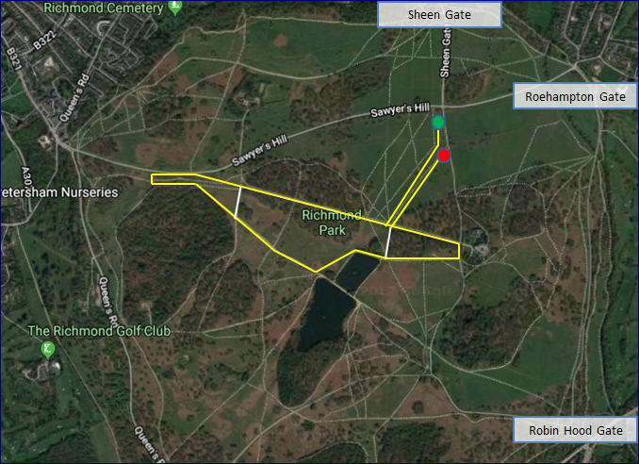

More information about the park, including a detailed map, can be found on the Richmond Park website.

TIMETABLE

Division 2 will be hosting their race at the same location at 130pm.This is hosted by the Stragglers. Division 1 races are hosted by Ranelagh Harriers.
2:30 pm Juniors race Div 1. Approx 4080m - one lap.
3:00 pm Men's race Div 1. Approx 8300m - two laps.

COURSE

The park drains well. Unless there is heavy rain leading up to the event, short spikes or even road shoes are recommended, though trail shoes may be worn. Most of the course is on grassy paths but the run down to the Pen Ponds is stony and rutted in places.
From a wide and bumpy start, the course makes its way to the Jubilee Pond before following a grass path beside a brook to the foot of Queen’s Ride and the start of the lap.
Turn right and ascend Queen’s Ride, all the way up until the road is reached. Follow the road to a dip, where there is a narrow path on the left. After a short while, cross the horse ride where there is a large clump of reeds and immediately bear left, to join the main path around Sidmouth Wood. Follow this path all the way down the hill to the Pen Ponds. Turn left before the ponds onto the grass then bear right to run beside the lower Pen Pond. Continue up towards the Ballet School before two left turns lead to a descent to the bottom of Queen’s Ride and the end of the lap. Senior men will run two laps.
Turn right at the bottom of Queen’s Ride to follow another grass path beside the brook to the finish.
The junior race is just one lap. For this lap, the course misses out the section up to the Ballet School, cutting left towards the bottom of Queen's Ride immediately after passing the lower Pen Pond.

BANNERS, TENTS, BELLS AND HORNS
The Royal Parks Agency has agreed to the erection of banners and flags, in a marked area alongside the start. However, tents are not permitted. Neither is the use of cow bells, horns or similar instruments.
Please abide by these instructions and do not jeopardise the future use of the park for races.
TRANSPORT
Richmond Park covers a large area and is bounded to north by the A305 and A205 (South Circular Road) between Richmond and Barnes, to the west by the A307 between Richmond and Kingston, to the south by the A308 and A3 between Kingston and Roehampton and to the east by the A306 through Roehampton.
There are five vehicle entrances to Richmond Park: Roehampton Gate (north east), Sheen Gate (north), Richmond Gate (north west), Ham Gate (west) and Kingston Gate (south west).
For travel by public transport, please consult the National Rail and Transport for London websites.
The closest railway stations are at Richmond, Mortlake, Barnes and Kingston and are part of the South Western Railway network.
From Richmond or Kingston stations, take the 371 bus to the American University bus stop. Richmond Gate is around the corner and from there it is approximately 1¼ miles to Sheen Cross roundabout. From Mortlake Station, Sheen Cross roundabout is approximately 1¼ miles via Sheen Lane and from Barnes Station approximately 1¾ miles via Priory Lane.

PARKING
The nearest car parks are at Sheen Gate and Roehampton Gate. Both are within ½ mile of the start.
The park authorities have asked that no vehicles use the Pembroke Lodge car park(which in any case is further from the start than the car parks mentioned above). There is also no car parking at the Ranelagh Clubhouse.
Please be aware there is no vehicle access at Robin Hood Gate and that gates allowing vehicle access to Richmond Park will be closed shortly before dusk – please check the times which are displayed on the gates as you enter the park by road.

FACILITIES

There are no changing facilities. Please come ready changed.

Toilets are available at Sheen Gate, Roehampton Gate and Robin Hood Gate car parks. Some of the toilets in the park may incur a 20p charge for use.

There is a café at Roehampton Gate car park

HOSPITAL

The nearest hospital is Kingston Hospital, Galsworthy Road, Kingston KT2 7QB. Tel: 020 8546 7711. (exit the park via Kingston Gate). A defibrillator is available in Pembroke Lodge

RICHMOND PARK

Richmond Park has protected status as an important habitat for wildlife and is a National Nature Reserve, London's largest Site of Special Scientific Interest and a European Special Area of Conservation. Please follow Sir David Attenborough’s request to Tread Lightly in Richmond Park.

Please be aware that the deer in Richmond Park are wild animals, roam freely and can be unpredictable, particularly as the race takes place during their rutting season. You are advised to give stags a wide berth. Also be aware of the presence of ticks and oak processionary moth.

Please also respect the other visitors to park, who have as much right to be there as we do.

